**TEAM MEMBERS DETAILS**

|  |  |  |
| --- | --- | --- |
| **SI.NO** | **NAME** | **MAIL ID** |
| 1 | KODELA ANAND VASU | anandvasukodela6046@gmail.com |
| 2 | MUSTURU YOGESH REDDY | yogeshreddy473@gmail.com |
| 3 | KOTHAPALLI VENAKATA GOPINADH | Kvgn2283@gmail.com |
| 4 | KOMARABATHINI KANAKESH BABU | kanakeshkittu@gmail.com |

**Project Document**

**SLA Implementation for Priority 4 Hardware-Related**

**Incidents in ServiceNow**

# 1. Project Overview

To design, implement, and manage a Service Level Agreement (SLA) for hardware-related incidents categorized as Priority 4 within ServiceNow. The goal is to ensure that these incidents are effectively tracked and resolved within 16 business hours, incorporating SLA pauses when incidents are placed on hold and stopping the SLA when incidents are resolved or closed.

**2. Objectives Primary Goal:**

Ensure that all Priority 4 hardware-related incidents are resolved within 16 business hours, contributing to improved incident management efficiency and better end-user satisfaction.

**Objectives:**

* Successfully configure the SLA within ServiceNow to match the specified business criteria.
* Implement workflows to automate SLA timing (start, pause, and stop).
* Provide stakeholders with real-time data on SLA performance and breach alerts.
* Document and train staff on the SLA’s operational and escalation protocols.

# 2. Key Features and Concepts Utilized

SLA Configuration in ServiceNow – A fully configured and automated SLA for Priority 4 hardware-related incidents.

Automated Workflow Rules – Business rules that manage SLA pauses and stops.

Reporting Dashboards – Customizable dashboards and real-time reports for SLA tracking.

Testing Results – Validation and documentation of SLA testing outcomes.

Training and Documentation Materials – End-user training sessions, user guides, and SLA workflow documentation

# 4. Detailed Steps to Solution Design

The project scope includes:

1. SLA Definition and Configuration in ServiceNow:
   * Define the SLA parameters for Priority 4 hardware-related incidents.
   * Set the response and resolution targets to 16 business hours.
2. Workflow Automation:
   * Automate the SLA to start counting upon incident creation.
   * Configure the SLA to pause when the incident status changes to “On Hold.” o Set conditions to automatically stop the SLA when the incident status changes to “Resolved” or “Closed.”
3. Reporting and Monitoring:
   * Develop reporting mechanisms to track SLA compliance. o Create dashboards for visibility on SLA performance metrics.
   * Configure alerts for potential SLA breaches.
4. Testing and Validation:
   * Test the SLA configuration in a ServiceNow development environment. o Validate that SLA pauses and stops function accurately according to the defined business rules.
5. User Training and Documentation:
   * Train service desk personnel on SLA usage and monitoring. o Create documentation for SLA management and escalation procedures.

**Screen shots:**

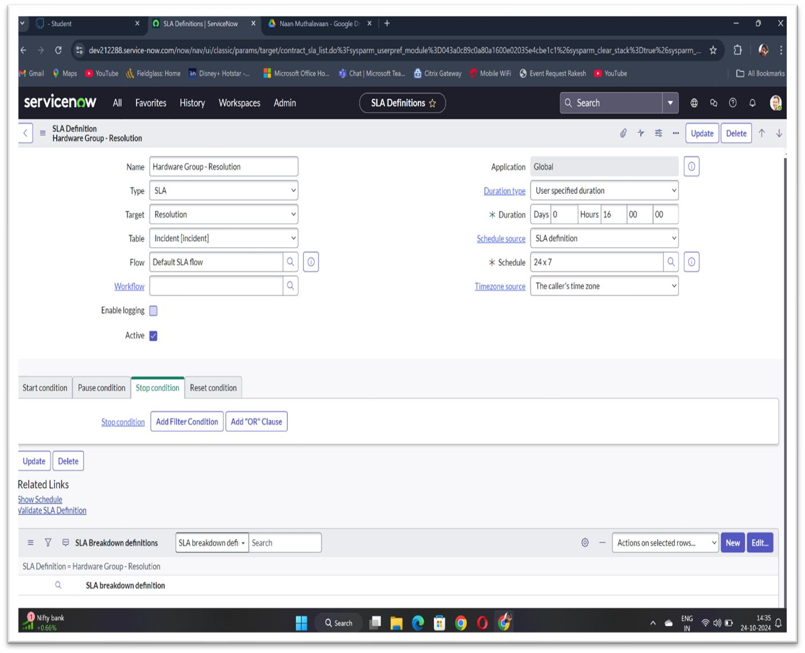

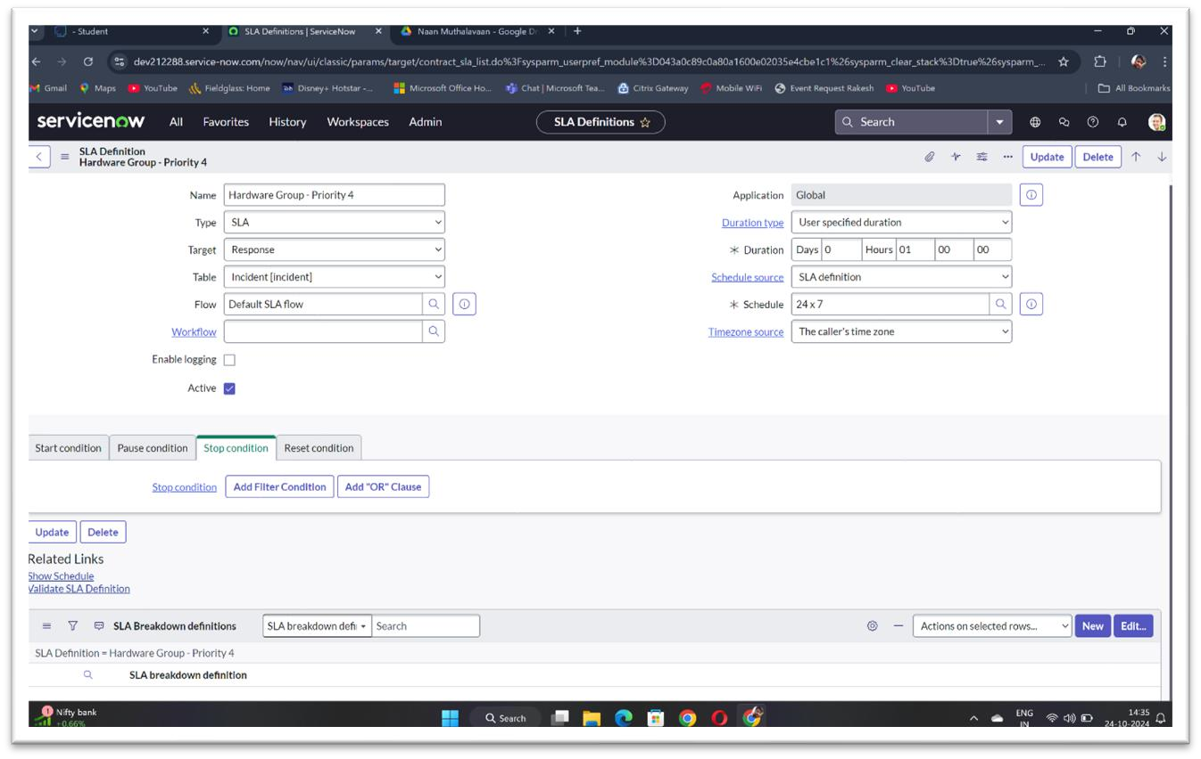

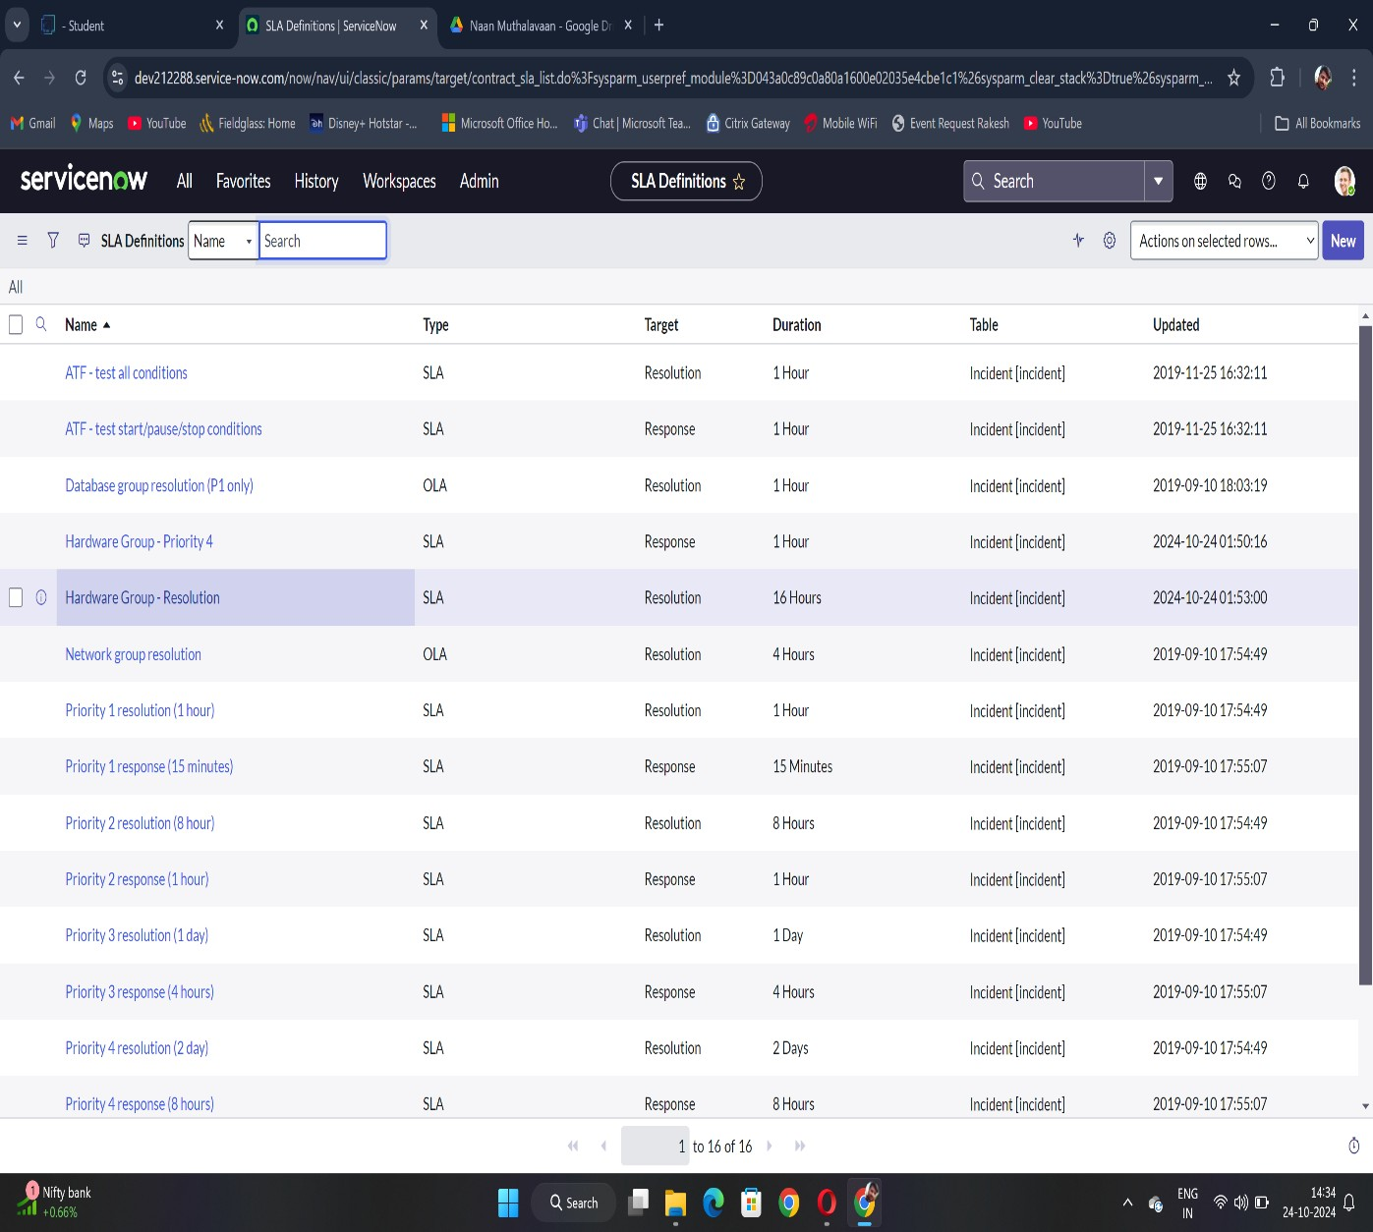

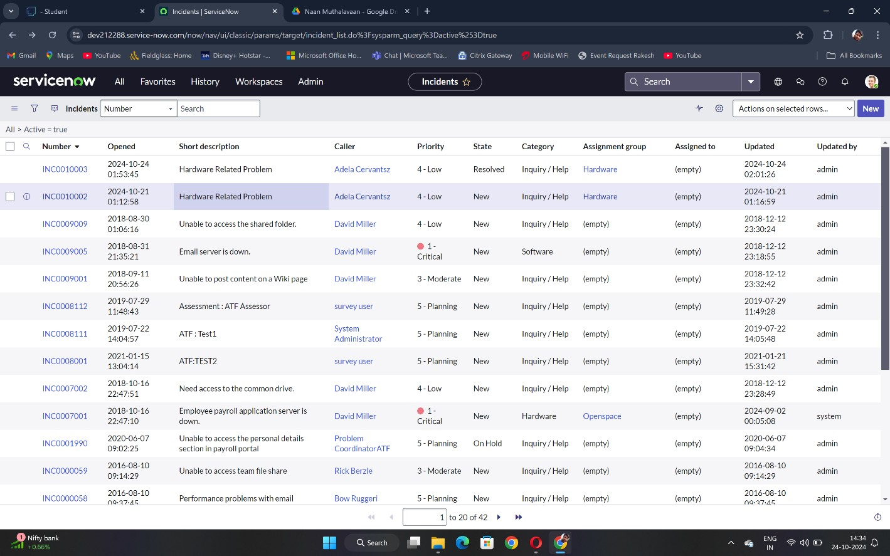

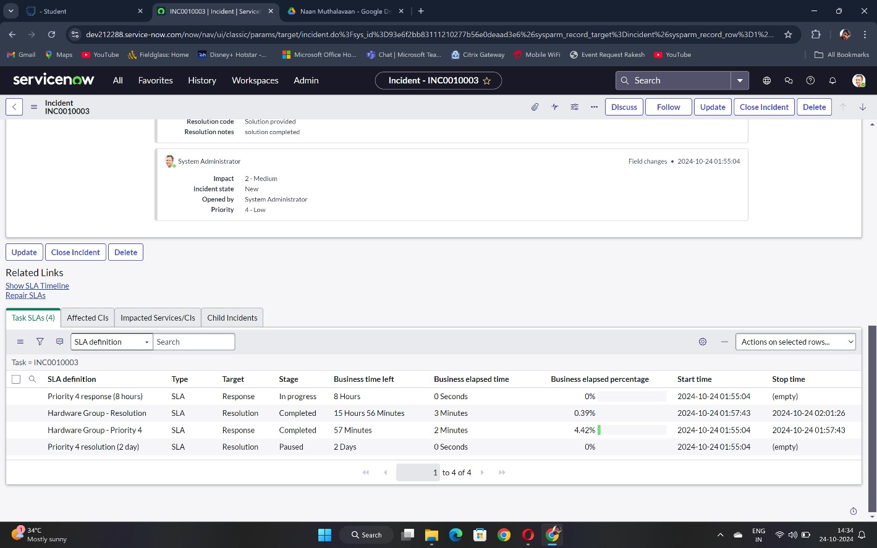

# 5. Testing and Validation

Describe the approach to testing:

**Components for testing:**

1. SLA Timer Initialization
2. SLA Pausing
3. SLA Resumption
4. SLA Stopping
5. SLA Breach Notifications
6. SLA Reporting Accuracy

## 6. Key Scenarios Addressed by ServiceNow in the Implementation Project

 Automatic SLA Assignment for Priority 4 Hardware Incidents

* Scenario: When a hardware-related incident is created and assigned a Priority 4 status, the SLA is automatically applied without requiring manual intervention.
* ServiceNow Solution: ServiceNow’s SLA engine detects the incident’s priority and category and applies the predefined SLA, setting the resolution target of 16 business hours.
* Benefits: Reduces manual tracking errors and ensures consistent application of the SLA to all relevant incidents.

 Real-Time SLA Countdown and Tracking

* Scenario: Service desk agents need visibility into the remaining time to resolve Priority 4 hardware incidents.
* ServiceNow Solution: ServiceNow displays the SLA countdown timer on the incident record, updating in real time and reflecting the time remaining until SLA breach.
* Benefits: Provides agents with clear visibility into SLA deadlines, encouraging prompt action on open incidents.

 SLA Pausing for "On Hold" Status

* Scenario: When an incident is placed “On Hold” (e.g., waiting for parts or customer feedback), the SLA should pause, so the time does not continue counting against the resolution target.
* ServiceNow Solution: ServiceNow configures the SLA to automatically pause when the incident is set to "On Hold" and resume when the status changes back to “In Progress.”
* Benefits: Ensures that external dependencies do not negatively impact SLA performance, allowing accurate tracking of actual working time.

 Automatic SLA Stop on Resolution or Closure

* Scenario: The SLA should stop automatically once the incident status changes to “Resolved” or “Closed,” ensuring the SLA is no longer active.
* ServiceNow Solution: ServiceNow stops the SLA timer and records the total time taken to resolve the incident once it’s marked as "Resolved" or "Closed."
* Benefits: Accurately reflects completion times and prevents SLA breaches for incidents that are successfully resolved or closed.

 SLA Breach Alerts and Notifications

* Scenario: Notifications need to alert agents and managers when an SLA breach is imminent or has occurred, prompting timely action to prevent or mitigate breaches.
* ServiceNow Solution: ServiceNow can be configured to send notifications and alerts when a Priority 4 SLA is close to breach (e.g., 1 hour remaining) and when a breach has occurred.
* Benefits: Improves incident management by proactively alerting stakeholders to SLA status, reducing breach occurrences.

 Comprehensive SLA Reporting and Dashboard

* Scenario: Managers require reports and dashboards to monitor SLA compliance rates, identify bottlenecks, and improve incident response times.
* ServiceNow Solution: ServiceNow provides reporting and dashboard capabilities, allowing managers to view SLA metrics for Priority 4 incidents, including time-toresolution, number of breaches, and time spent in each status.
* Benefits: Enables data-driven decision-making, identifies process improvement areas, and enhances overall SLA compliance and service quality.

 Incident Prioritization and Workflow Automation

* Scenario: Service desk agents need an automated prioritization system to handle incidents based on SLA requirements and urgency.
* ServiceNow Solution: ServiceNow automatically categorizes and prioritizes incidents with applied SLAs, ensuring Priority 4 hardware incidents are identified and addressed in line with their 16-hour resolution target.
* Benefits: Helps agents focus on critical incidents first, improving response times and SLA compliance.

 Testing and Validation Support in Development and QA Environments

* Scenario: IT teams need a way to test SLA configurations in a controlled environment to ensure accuracy before deploying to production.
* ServiceNow Solution: ServiceNow’s Automated Test Framework (ATF) enables simulation of SLA scenarios, testing SLA timing, pausing, stopping, and notifications in a development or QA environment.
* Benefits: Ensures that the SLA behaves as expected in production, reducing risk and improving reliability.

# 7. Conclusion

Summary of Achievements: The SLA implementation project in ServiceNow for Priority 4 hardware-related incidents addresses key operational scenarios critical to enhancing IT service management efficiency and effectiveness. By automating SLA assignment, countdown tracking, and real-time alerts, ServiceNow enables the IT team to manage and prioritize hardware incidents seamlessly, ensuring they are resolved within the specified 16business-hour target. The system’s ability to pause SLAs during "On Hold" periods and automatically stop them upon resolution or closure adds further accuracy, reflecting actual working times and reducing unnecessary breaches.

ServiceNow’s advanced reporting and dashboard functionalities also provide managers with essential insights into SLA performance, helping to identify bottlenecks, improve workflows, and promote data-driven decision-making. Testing and validation capabilities ensure the SLA functions as designed, mitigating potential issues before deployment and reinforcing service quality.

In conclusion, the ServiceNow SLA implementation provides a comprehensive, reliable solution for managing Priority 4 hardware-related incidents, ensuring compliance with SLA terms, improving incident response times, and ultimately contributing to higher levels of service quality and user satisfaction.